PhD title: Creative multimodal improvisation and performance
R.D. Brown , June 2013

Content:
- Research Questions
- Proposed Supervisors
- Background
- Overview
  - Multimodal Performance
  - Technical Outline
- Methodology
- Strategy
- Outcomes and Relevance
- Literature Review
  - Performative Research
  - Technology , performance and improvisation
  - Related Research
- References

1. Research Questions
1.1 Core Research Question

- How might multimodal technology produce new and innovative forms of live improvisational performance?

1.2 Secondary Questions
- What models and definitions of creativity and improvisation might be used in the context of technology and live performance?
- What forms of live improvisational performance can be produced using multimodal technology?

- What is the nature of the space between the real and the mediated, the improvised and the choreographed, and the viewed and the performed?

- How can mediated performance produce an engaging and immersive audience experience?

- What is the role of real-time improvisation in producing an engaging audience experience?

- How can technology assist improvised story telling rather than be used simply as means of generating spectacle?

2. Proposed Supervisors
Principal: Professor Steve Benford (Collaborative Computing, Computer Science, MRL).
Secondary : Dr. Gordon Ramsay (Drama and Performance, Faculty of Arts).
Advisor: Professor Chris Greenhalgh (Computer Science).

3. Background

Technology has been used over the last two centuries to produce theatrical illusions, ranging from Peppers Ghost and the Phantasmagoria of the nineteenth century to the more modern day presentations by Lepage, Punch Drunk, Forkbeard Fantasy, Forced Entertainment and Blast Theory.

Over the last fifteen years, the author has created a number of interactive installations that through a combination of projection, gestural sensing and real-time computing have produced engagement, immersion and a suspension of disbelief with participants. One of the key elements to achieving successful engagement is the seamless melding of content, interface and user experience. The relationship of content to interface, media and experience will be one of the particular strands I wish to examine through practice as research (PaR).

The concept of Performative Research (Haseman 2006) has a particular resonance to the type of practise I am envisaging and represents a new paradigm for research and has potential impact on the Digital Economies.

The PhD research methodologies of Practise As Research, Practise Led Research and the paradigm of Performative Research are discussed in detail in section 5. Methodologies.

Rather than the audience being an active participant of an interactive artwork, the author will be the medium or conductor through which the audience receives the experience. This type of performative work engages with concepts of improvisation and multiple trajectories, unfolding in real time and moving between scripted, generative, random, neural, chaotic, ordered and emergent. The relationships between performer, content, interaction and multimodal media types cannot be precisely defined at this stage and it is envisaged that these relationships will emerge through practise led research and the implementation of real world and “out in the wild” trials and experiments.

4. Overview

The research field is located in the intersection between Computer Science and the Performing Arts. The research will be informed by contemporary critical theory on performance and technology, producing an interdisciplinary enquiry illustrated in the diagram below:

Performance
History
Practice
Theory

Computer
Science
HCI
Critical Theory

The Computer Science/HCI research will focus on the use of natural computing interfaces such as gesture and voice, combined with high performance multimodal delivery audio, video, text and 3D graphics. The research further examines the necessary software and systems platforms that can provide engaging content production and performance delivery.

The research will also be influenced by contemporary critical theory on the relationships between performance, technology, culture and society. Critical Theory provides a rich source of multi contextual perspectives in philosophy, psychology, cognition and creativity.

The research will also draw on both the current and recent practise and history of technology related performance art and make reference to key critics and theorists, acknowledging performative notions of liveness, authenticity and improvisation.

4.1 Multimodal performance

A multimodal performance is set on a virtual stage, where a performer using a variety of natural modalities such as gesture, body movement and voice interacts with computer generated projections of scenes, actors and props. The technique of projection mapping results in believable illusions, realised by the design of video projection imagery that co-locates with real three dimensional objects. The object may be a building, a white cube a person or a face. This technique has been used in pop promos and advertising, creating virtual scenarios combined with real objects and live action. A further suspension of disbelief is created when an actor engages with the projections as if they were real.

A convincing example of this technique can be seen in the screen shots below from the pop promo (Willow 2012), where the singer, using a simple treadmill to convey the physical act of walking through the scenes, apparently opens virtual doors, walks through rooms, rides down an escalator and travels in a train, all occurring in one virtual set.

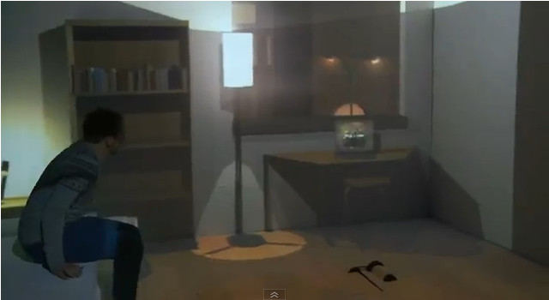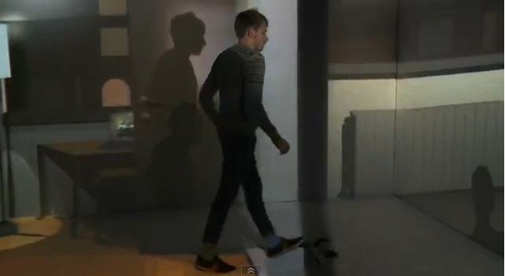
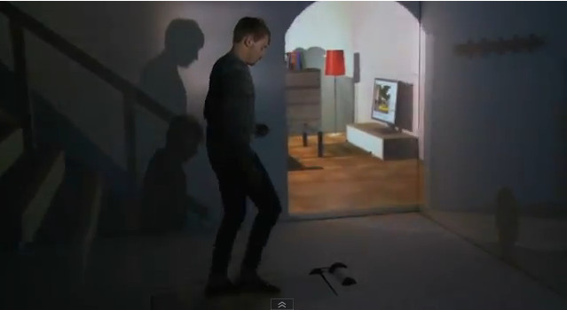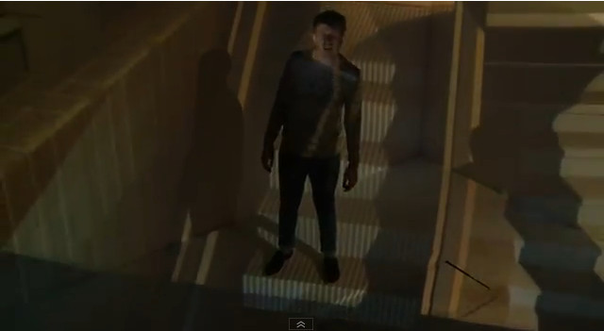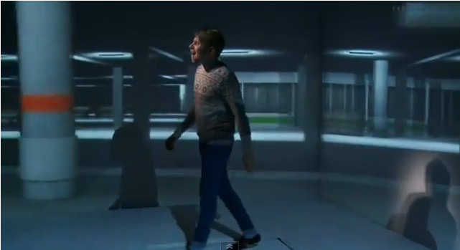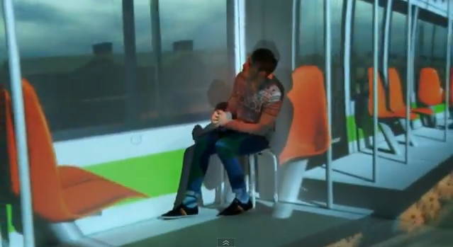

In this example the actor has to rehearse and time his interactions to fit the pre-generated computer graphics backdrops.
A key element of the research is the investigation of real-time interaction and improvisation within a virtual set, such that virtual objects respond to the actor with pre-scripted behaviours. A virtual candle might go out when blown or reignite with a virtual match, a light switch would turn off and on a light and a door would open when pushed.
Scripted objects are common artefacts in computer gaming, and it is expected that Games Engines and associated tools are likely to provide suitable vehicles for creating and delivering interactive virtual sets, objects and characters.

In the virtual set, a performer will be able to take on the role of any number of projected characters – similar to the concept of avatars in computing gaming. Advanced HCI techniques would enable the projected character not only to directly follow the movements of the performer, but also to lead the performer into mimicking its movements. For example a projection of an elderly avatar would require the performer to move slowly and hesitantly, attempting to match or mimic the lead of the character. The technique might be further developed into movement training with applications in sports, dance and health.

4.2 Technical Outline

A system for delivering multimodal performance would comprise of projection mapping (single or multiple projectors), 3D body interfacing (for one or more performers) and real time 3D content generation.

A minimal system might comprise of a projector, a games PC with a Games Engine such as Unity 3D interfaced to a Microsoft Kinect for 3D body, gesture tracking and voice recognition. It is envisaged that a headset would deliver a live feed of the performer on stage, producing a sense of immersion and engagement as the performer sees his or her self in character and located in the virtual set.

A software model of a multimodal performance would represent the 3D content of the sets, objects and characters, an encoding of the dynamic and interactive behaviour of its characters and a model of potential trajectories or paths through scenes.
The research would investigate appropriate strategies for dynamic three-dimensional content representation, the support of improvisation and the encoding of trajectories in the model.

5. Methodology

Practise will be a key component of the methodology. A similar methodology, “testing in the wild” where projects are evaluated in the public domain has been incorporated in Horizon Research led PhD projects such as “A conversation Between Trees” by Rachel Jacobs (Jacobs 2013) and “Sculpture Garden” by Lesley Fosh (Fosh 2013).

Within the arts, Practice Based Research is common, where the practice of art and its resultant outcomes are considered as the main PhD output rather than only a written thesis. The output of a practice based research is twofold - an artefact, the creative output and an exegesis, a written commentary on the method of practice and a critique of its results.

Another variant is Practise Led Research, which examines art practises in order to drive the research, the main output is in written form and the production of an artefact is not a key element.

There are two types of practice related research: practice-based and practice-led:
1. If a creative artefact is the basis of the contribution to knowledge, the research is
practice-based.
2. If the research leads primarily to new understandings about practice, it is practice-led.
(Candy 2006)

Performative Research (Haseman 2006) represents a relatively new practise informed methodology which describes a type of research primarily associated with the performing arts.

Haseman believes performative research offers a new paradigm with special value to the creative industries due to its inherent practical application rather than the pure theoretical concerns often associated with academic research.
Further information on Performance Research can be found in the Literature Review.

It is envisaged that practise (experimentation, prototyping, testing in the wild) will lead the proposed research and that an exegesis and outputs from practise, such as video, software, documentation and analysis will form the PhD.

6. Strategy

The overall approach to the research will be in three phases, pre-production, production and post-production each phase approximately a year in duration with each phase informing subsequent phases.

Research outcomes will be in the form of artefacts such as video, events, software and a written exegesis which addresses, elucidates and contextualises the artefacts. Other outcomes are likely to be in the public domain consisting of exhibitions, happenings, performances and associated documentations of press, PR coverage, videos, websites, catalogues and posters.

I envisage my initial role as systems creator, developer and practitioner but leading to collaborations and workshops with other performers and technical specialists.

Notions of the Uncanny and the Double (Causey 2006) are seen as sources of inspiration for content production. Early scenarios will be developed to rehearse performative and improvisational content on the prototype performance system.

During this first phase the technical effectiveness and creative potential of the prototyping technology will be assessed resulting in an evaluation and working proposal for subsequent phases.

Phase 1 (Pre-production)
1.1 Literature review and “artistic audit” (Haseman 2006:8) leading to formulations for practise.
1.2 Assess and identify suitable technologies for preliminary experiments, ideally consumer or off the shelf. Produce outline system proposal.
1.3 System acquisition, testing and prototyping.
1.4 Workshops and collaborative exercises (eg Broadway, Hatch, University Theatre)
1.5 Documentation and ethnographic studies.
1.6 Phase 1 critical evaluation and assessment, detailed plans for phase 2 and outline phase 3.

Phase 2 (Production)
2. As a result of Phase 1, specify production systems and associated information structures, content storage and generation.
2.2 Storyboarding. In the wild enactments.
2.3 Documentation. Assessments, auto and ethnographic.

Phase 3 (Post-production)
3.1 Final testing, refinements, performances and documentation.
3.2 PhD exegesis and assembly of artefacts and associated documentation.

7. Outcomes and Relevance

The authors own experience is that art as a mode of enquiry can impact not only on science but also the development of technology. The creation of artistic renderings of dynamic 3D neural nets in the sci-art Biotica project (Brown 2001) led to insights for the scientist Igor Aleksander in conceptualising new forms of neural net structures that were previously conceived as static designs in two dimensions. The industrial sponsor of the project Intel recognised that creative research challenged conventional hardware and software paradigms, suggesting the need for parallel graphics processing and novel gestural interfaces for the hardware of the future. These concepts were delivered via a report and lecture to research staff at Intel headquarters in Oregon in 2000.

The author is confident that the practise led research using performance as a mode of enquiry will impact and inform both the cultures of Computer Science and the performing arts and will also find potential application in the creative industries.

It is speculated that the research will generate new forms of content, new interfaces and new paradigms for interaction, content production, delivery and consumption.

It is expected that the research will result in the publication of essays and papers bridging disciplines between computer science, HCI, performance theory and practice, and contemporary critical theory.
It is hoped that new knowledge will be generated as a result of this intersection of performance, HCI and computing driven by practice and informed by critical theory.
The creation of working prototypes is also likely to result in working papers, systems specifications, software tools and production methodologies.

The research will be documented in written form and multimedia. Further outcomes might include exhibitions, and live performances, with associated media coverage.

In the future it is also hoped that the research will lead industrial collaborations with 3D gaming systems and software development companies such as Microsoft and Crytek.
Collaboration with relevant academic intuitions both in the UK and abroad may also prove beneficial for research and development.

8. Literature Review
In order that both the research and its outcomes maintain a critical edge technically, conceptually and culturally the literature review encompasses three interrelated areas – computing systems and HCI, critical theory, performance theory and practise.

Critical theory is seen as important as it acts as a bridge between technology and culture, revealing new insights and alternative perspectives of the complex relationships between creativity, expression, performance, society, culture and technology.

In addition literature research has revealed different methodologies and examples of Phd by practice (PaR, PlR and PR) which will inform the methodology, an overview of the literature in this field is included in the review.

Haseman suggests that the literature research embodies an “artistic audit” – an overview and review of contemporary practise.

For example, one emerging method – known as an artistic audit – is explicitly designed to transform ‘the literature review’ into a more layered and rich analysis of the contexts of practice within which the performative researcher operates. Undertaking an artistic audit is essential for the practice led researcher who, for example, is investigating the inter-relationship between the live body and projected image in performance. As researchers ‘practice’ and make such a work, it is essential they reach beyond their own labours to connect with both earlier and contemporaneous productions which contribute to the overall research context for their work.
Haseman (2006:8)

The artistic audit will be ongoing, and the literature review includes an initial review of the field in related research.

8.1 Performative Research

Taking its name from J.L. Austin’s speech act theory, performative research stands as an alternative to the qualitative and quantitative paradigms by insisting on different approaches to designing, conducting and reporting research. The paper concludes by observing that once understood and fully theorised, the performative research paradigm will have applications beyond the arts and across the creative and cultural industries generally.
(Haseman 2006).

Haseman believes performative research offers a new paradigm with special value to the creative industries due to its inherent practical application rather than the pure theoretical concerns often associated with academic research.

Performative research – while it has been fuelled by the practices of
artist/researchers and is the most appropriate research paradigm for all forms of artistic practice – is also being used by researchers involved in content creation and production across the creative and cultural industries, especially those engaged in user-led and end-user research.
(Haseman 2006:9)

Gray makes an interesting distinction between what might be termed classical scientific positivist research and creative practise which tends to be constructivist.
For instance, the positivist paradigm of inquiry is characterised by a realist ontology (reality exists ‘out there’), and an objectivist epistemology (the researcher is detached); methodology is therefore experimental and manipulative; in contrast, the constructivist paradigm is characterised by a relativist ontology (multiple realities exist as personal and social constructions) and the epistemology is subjectivist; methodologies are hermeneutic (interpretative) and dialectic.
Gray (1996:12)
In the context of the Computer Science orientated Horizon DTC program these distinctions are important to recognize and understand especially in terms of “cultural fitness” and acceptable research methodologies. One might argue that we are in the realms of the two cultures, the science and the humanities (Snow 1959). More recently, Lev Manovich wittingly describes the conceptual schism between computing and the arts in terms of two psychic geographies – Turing Land vs Duchamp Land (Manovich 1996).

One of the resultant benefits of bringing the two cultures together is the osmosis of information, finding concepts that mutually inform the two disciplines. The art science debate continues to flourish with questions asking how art might impact on science, whilst it is generally accepted that science continually informs the arts.

Academic research paradigms may also require a shift to accommodate new research methodologies that embrace practice as a fundamental element of research.
If practice-led research remains primarily a postgraduate concern, then discussions around this form of research will continue to be dominated by compliance issues—attempting the ‘best fit’ between practice-led research and traditional, slow-moving, academic research protocols. In this view, research methodology, use of theory, documentation and archiving, and the articulation of knowledge claims are framed around appeasing institutional requirements. But the practice-led community needs to sets its sights higher and wider. The innovation framework and agenda, linking research to application, diffusion, education and culture, might just be the key. At the very least, we can use it to unlock our horizons and impact.
(Jaaniste 2009:11)

And
The admission of creative practice in a PhD context is premised on the notion that research questions in the performing arts can be rigorously worked through in a range of practices (of which writing is only one).

Practice should be accepted as methodological process of research inquiry and a mode of dissemination of research in its own right.
(http://www.bris.ac.uk/parip/par_phd.htm)

8.2 Technology , performance and improvisation

Computer-aided improvisation is generally associated with music and there is an overwhelming amount of research literature in this field, probably because electronic music has a long history in connection with computing and music with its close relationship to mathematics is more amenable to digital representation and mediation than visual performance.

The Performing Arts, especially dance, tend to use technology as interpretive media rather than for live improvisation. There is a gap in the use of technology for the production of live multimodal improvisation combining voice and gesture with mediation.
The paper “Liveness and the machine : Improvisation in Live Audio-Visual Performance” Cooke (2011) describes live audio-visual performance as an emerging area of new media arts practice that crosses between, and draws upon, multiple artistic traditions and trajectories. Cooke refers to the parallels with VJing, Live and Expanded Cinema and examines concepts of liveness in relationship to improvisation and spontaneity.

Liveness and authenticity are important concerns within the culture of performance, especially in relationship to documentation and technological mediation (Auslander 2008).

The relatively new term ‘comprovisation’ describes a semi structured space somewhere between composition and improvisation.
Likewise, many writers on improvisation testify to the problematic of distinguishing between spontaneous creation and pre-existing structure or motif; the term ‘comprovisation’ has arisen as a way of recognising the intricate interweaving of the com-posed with the improvised.
Cooke (2011:11)

A conference on technology and the performing arts entitled “Comprovisations” held in 2010 (Bhagwati 2010) discussed how technologies would transform the aesthetics and practises of stage performance and engender new production modes as well as call into play audience reactions to technology enhanced performance.
Contributors to the workshops were predominantly electronic music performers, probably because comprovisation is a term associated with improvised music – a place in between improvisation and composition.

Due to the abundance of research in music improvisation and technology, research of the differences and potential overlap between music and the visual arts is required to determine if there are any common grounds between visual and aural languages. This area might also be further understood through the methodologies of multimodal studies and semiotics. The following quote with its multiple references indicates a wide area of research in this field.

In the first sense, multimodal studies applies existing generalisations (of theory, description, methodology) to the exploration of specific multimodal phenomena, sets of texts or contexts in order to cast new light on those domains. Such domains might be more broadly defined areas of multimodality; e.g. ‘language of displayed art’ (O'Toole, 1994), ‘grammar of visual design’ (Kress & van Leeuwen, 2006), ‘speech, music, sound’ (van Leeuwen, 1999), ‘mathematics discourse’ (O'Halloran, 2005); particular (sets of) semiotic resources in interaction; e.g. images and text (e.g. Martinec, 2005; Unsworth & Cleirigh, 2009) and gesture and phonology (e.g. Zappavigna, Cleirigh, Dwyer, & Martin, 2010); or sites where multimodal discourse is at issue, such as classroom discourse (e.g. Clarke, 2001; Jewitt, 2006), and interactive digital media such as games, the internet, video and corporate advertising etc (e.g. Jewitt, 2009; Ventola & Moya, 2009).
(O’Halloran 2011:4)

In the paper “Designing the Spectator Experience” (Reeves 2005), the spectator’s perception of differing types of perceived interactions with technology are analysed in order to suggest a taxonomy of modalities:

Our taxonomy uncovers four broad design strategies: ‘secretive,’ where manipulations and effects are largely hidden; ‘expressive,’ where they tend to be revealed enabling the spectator to fully appreciate the performer’s interaction; ‘magical,’ where effects are revealed but the manipulations that caused them are hidden; and finally ‘suspenseful,’ where manipulations are apparent but effects are only revealed as the spectator takes their turn.

The audience’s perception and comprehension of technology enhanced performance is recognised as an important if not problematical research area, with the term “The Disembodiment Problem” (Marrin Nakra 2000) used to describe the disjunction between cause and effect when using interactive technology to produce music. This problem can also be viewed as a challenge and perhaps a quality of technology when used in a performance context and is treated as such in the paper “Disembodied Performance: Abstraction of Representation in Live Theater” (Torpey 2009).

Balme (2009) suggest that theatre acts as a location for intermediality and as a location for the hypermedia.

If intermediality is to be taken as a historical paradigm, then theatre must be understood in the first instance as a hypermedium that was always capable of incorporating, representing and on occasion even thematizing other media.
Balme (2009:90)

The concept of hypermediality and theatre resonates with Marinetti’s Futurist concept of Synthetic Theatre (Marinetti 1915), where all media and forms of expression were to be incorporated to produce a new type of dynamic and simultaneous theatrical experience. Dixon, a modern practitioner in the field suggests that futurism paved the way for digital performance.
Digital performance’s historical lineage is precisely and inextricably linked to the philosophies, aesthetics and practices of the Futurist movement.
(Dixon 2005:2)
The book “Digital Performance: A History of New Media in Theatre, Dance, Performance Art, and Installation “ (Dixon 2007) examines the connections between technology, theatre and performance over the last century, with examples by many artists of differing interactive and theatrical technology based works.

In The Screen Test of the Double: The Uncanny Performer in the Space of Technology, Causey (1999) combines a number of perspectives from critical writings on performance including Philip Auslander and Peggy Phalean in order to examine the relationship between the real, the virtual and the performer in a mediatised culture. In his analysis, Causey takes a “psycho philosophical” approach to the relationship of performance and technology drawing on the writings of Lacan and Freud, citing provocative concepts such as the Double and the notion of the Uncanny.
In Theatre and Performance in Digital Culture, Causey (2009) further examines the relationships of technoculture, ubiquitous information and its cultural embeddedness to theatrical practise.

8.3 Related Research
Jo Scott is an artist and research student investigating “New Forms of Liveness in Live Intermedial Performance”

This practice-as-research project addresses liveness in performance and investigates its construction and manifestation, specifically within an intermedial context. Taking as its starting point definitions of liveness posited by Peggy Phelan, Philip Auslander and Erika Fischer-Lichte, the focus of the research is to interrogate such definitions through practice. (Jo Scott 2013)

In her paper, “Dispersed and Dislocated: The construction of liveness in live intermedial performance”, Scott (2012) discusses how her practice based research informs theories on liveness and intermediality, arguing that two essential elements to creating a sense of liveness is the real-time nature of the technology enhanced performance unfolding in space and time and the unpredictability of its direction at any moment in time.

Christopher Maraffi is a practioner and researcher who combines computer science, art and performance.

My academic background is in the arts, with a bachelors of creative arts in painting and a masters of fine arts in new media with a performing arts focus. As a physical performer, I have over 10 years experience as a dancer, mime, and martial artist. My computer science PhD thesis consists of a critical technical practice to bring the arts and aesthetics to the center of AI research for virtual character control in playable media.
(http://www.chrismaraffi.com/performatology.html)

Maraffi coined the term Performatology to describe the computer control and interface of humans to virtual actors.
We define a Performatology approach as combining performing arts theory with AI to design Performative Embodied Agents (PEAs) that simulate skilled acting. Our position is that NPC characters for interactive drama, in the traditions of theater and cinema, should be animated by agent behavior modeled on the physical acting of live performers. We propose that agent behavior problems related to generating embodied fictive characterizations are at least in part gestural acting problems that have been addressed in the arts domain. Actors, puppeteers, and animators have successfully portrayed fictive characters that are both believable and appealing to audiences, and therefore similar agent generated characters should attempt to simulate their techniques.
(Maraffi 2011)

Adaptive Digital Media Lab, Georgia Tech
The ADAM Lab explores the intersection between cognition, creativity and computation through the study of creative human endeavors and by building digital media artifacts that represent and/or our findings. Applications of our findings range from AI-based digital performance to interactive narrative experiences to educational media design and development.
The Digital Improv Project is a three-year long investigation into the roots of human creativity, as it relates to the development of artificial intelligence (AI). Started in 2008, the Digital Improv Project will examine the cognitive functions of improv actors through the process of protocol analysis and behavioral coding. The end goal of this process is to establish algorithms for creativity that can then be transferred to virtual characters. The proposed beneficiaries of this research will include AI specialists, game designers, and cognitive scientists.
(adam.lmc.gatech.edu/)

9. References

Auslander, P. (2008) Liveness: Performance in a Mediatized Culture, London and New York: Routledge.

Balme C. (2008): Surrogate Stages: Theatre, Performance and the Challenge of New Media,
Performance Research: A Journal of the Performing Arts, 13:2, 80-91
http://www.tandfonline.com/doi/pdf/10.1080/13528160802639342 [15/4/2013]

Bournemouth (2011) Guidelines: additional guidance for practice-led research degrees.
https://staffintranet.bournemouth.ac.uk/media/policiesprocedures/Guidelines%20-%20Additional%20Guidance%20for%20Practice-Led%20Research%20Degrees%20FINAL.pdf
[15/4/2013]

Brown, R., Aleksander, I., Mackenzie, J., Faith, J. (2001) Biotica: Art, Emergence And Artificial Life. RCA Computer Related Design Research; 1st edition (20 Mar 2001).

Bhagwati, S. Comprovisations: Improvisation Systems in Performing Arts and Technologies, Special Focus Symposium at the 22nd International Conference on Systems Research, Informatics and Cybernetics Baden-Baden (Germany), Aug 2-6, 2010
http://www.h-net.org/announce/show.cgi?ID=173733 [15/4/2013]

Candy, L. (2006) Practice Based Research: A Guide. CCS Report: 2006-V1.0 November
Creativity & Cognition Studios, University of Technology, Sydney.

Causey. M (2009) Theatre and Performance in Digital Culture: From Simulation to Embeddedness. Routledge.

Concordia (2012) Comprovisations – Improvisation Technologies for the Performing Arts.
http://matralab.hexagram.ca/comprovisations2012/about/ [15/4/2013]

Cooke, G. (2011) LIVENESS AND THE MACHINE: Improvisation in Live Audio-Visual Performance. Screen Sound, vol. 2, pp. 9-26.
http://epubs.scu.edu.au/sass_pubs/807/ [15/4/2013]

Dixon, S. (2005) Futurism e-visited.
http://www.paulj.myzen.co.uk/blog/Futurism/wp-content/uploads/2007/10/Futurism-e-visited-sm.pdf [15/4/2013]

Dixon, S. (2007) Digital Performance: A History of New Media in Theater, Dance,
Performance Art, and Installation. Cambridge: MIT Press.

Fosh, L., Benford, S., Reeves, S., Koleva, B., Brundell, P. (2013)
See me, feel me, touch me, hear me: trajectories and interpretation in a sculpture garden.
Proceedings of the SIGCHI Conference on Human Factors in Computing Systems, Pages 149-158, CHI '13. ACM New York, NY, USA ©2013. ISBN: 978-1-4503-1899-0. DOI: 10.1145/2470654.2470673

Haseman, B. (2006) A Manifesto for Performative Research.
Media International Australia incorporating Culture and Policy, theme issue "Practice-led
Research"(no. 118):pp. 98-106.
http://eprints.qut.edu.au/3999/01/3999_1.pdf [15/4/2013]

Jacobs, R., Bedford, S., Selby, M., Golembewski, M., Price, D., Giannachi G. (2013)
A conversation between trees: what data feels like in the forest.
Proceedings of the SIGCHI Conference on Human Factors in Computing Systems, Pages 129-138, CHI '13. ACM New York, NY, USA ©2013. ISBN: 978-1-4503-1899-0. DOI: 10.1145/2470654.2470673

Jaaniste, L. O., Haseman, B. C. (2009) Practice-led research and the innovation agenda : beyond the postgraduate research degree in the arts, design and media.
In: ACUADS 2009 Conference : Interventions in the Public Domain, 30 September - 2 October 2009, Queensland College of Art, Griffith University, Brisbane, Queensland.
http://eprints.qut.edu.au/31813/1/c31813.pdf [15/4/2013]

Manovich, L. (1996) The Death of Computer Art, Rhizome, October 23, 1996,
http://rhizome.org/discuss/view/28877 [15/4/2013]

Maraffi, C., Jhala, A. (2011) Performatology: A Procedural Acting Approach for Interactive Drama in Cinematic Games, UCSC Computational Cinematics Studio, 2011.

Marrin Nakra, T.A. (2000) Inside the Conductor’s Jacket: Analysis, Interpretation
and Musical Synthesis of Expressive Gesture. Massachusetts Institute of
Technology, Ph.D. Thesis, 2000. (Chapter 8)
http://hdl.handle.net/1721.1/9165 [15/4/2013]

Gray, C. (1996) Inquiry through practice: developing appropriate research
Strategies.
http://carolegray.net/Papers%20PDFs/ngnm.pdf [15/4/2013]

Scott, J. (2013) New Forms of Liveness in Live Intermedial Performance.
http://www.cssd.ac.uk/students/profiles/jo-scott [9/6/2013]

Scott, J. (2013) Dispersed and Dislocated: The construction of liveness in live intermedial performance.
http://people.brunel.ac.uk/bst/vol1101/joscott/home.html [9/6/2013]

Snow. C.P. (1959) The Two Cultures and the Scientific Revolution.
http://en.wikipedia.org/wiki/The_Two_Cultures [15/4/2013]

Torpey, P. A. (2009) Disembodied Performance: Abstraction of Representation in Live Theater. S.M. Thesis: Massachusetts Institute of Technology, Media Arts and Sciences, 2009.
http://web.media.mit.edu/~patorpey/publications/torpey_sm_thesis_2009_disembodied_performance.pdf [15/4/2013]

O’Halloran, K. L., Smith, B. A. (2011) Multimodal Studies. In K. L. O’Halloran & B. A. Smith (eds) Multimodal Studies: Exploring Issues and Domains. New York & London: Routledge.
http://multimodal-analysis-lab.org/_docs/pubs10-Multimodal_Studies.pdf [15/4/2013]

Reeves, S., Benford, S., O’Malley,C. Fraer, M. (2005) Designing the Spectator Experience
CHI '05 Proceedings of the SIGCHI Conference on Human Factors in Computing Systems
Pages 741-750.
http://eprints.nottingham.ac.uk/archive/00000252/01/p133-reeves.pdf [15/4/2013]

Willow (2102) pop-promo video.
http://www.youtube.com/watch?v=cl8ptneR1Kk [8/6/2013]

