Practice as Research:
Intermedial performance, interaction and improvisation
R. Brown 31/3/2016

Contents
Research Overview 2
The Research Practice Process 3
Summary of Research Practice 3
Emergent Research Strands 6
Performative Interaction 8
Interaction Workshop 9
Participation 10
Navigation 10
The Embodied Performative Turn 11
iMorphia and Gaming 11
Corporeality, immersion and embodiment 12
Avatar Representation 15
Intermediality and iMorphia 16
Improvisation and iMorphia 17
The Uncanny And The Double 19
Theatre and Media Technologies 21
Digital Theatre 22
Technology and theatre research 22
References 24

Research Overview

This document describes the research territory resulting from an inquiry into the overlap between performance and intermediality. The research is situated in the wider field of crossover between theatre and media technologies dating back from the Phantasmagoria of the early 20th Century, through film, video and the more recent interactive digital multimedia. A brief overview of the wider historical context is described in the section, Theatre and Media Technologies.

The research adopts the “practice as research” methodology advocated by Robin Nelson (Nelson 2013) where the research is informed through both practice and theory, such that they are “imbricated within in each other” (Nelson 2013: 61 ).

The research practice involved the creation a prototype intermedial stage, iMorphia, evaluated through a series of documented workshops with performers and autoethnographic enactments. The outputs of this research process being recorded on the research website in the form a research blog.

The research theory has been informed by literature on intermediality, performative interaction and gaming, illustrated diagrammatically below (Diagram 1).

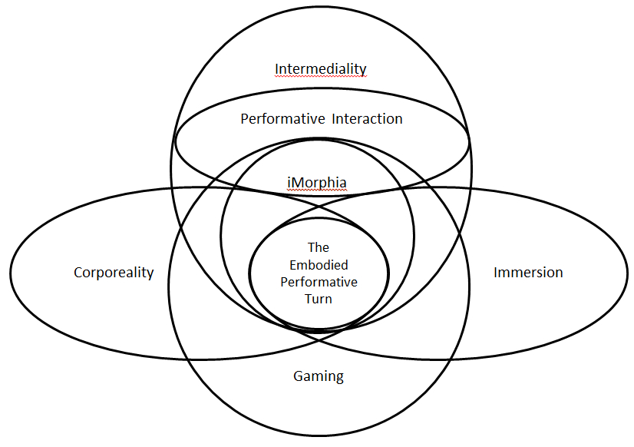
Diagram 1: Map of research territory

The conceptual areas and crossovers are unpacked in the following sections, firstly looking at the creation of iMorphia through an evolving research practice and the potential research directions generated through the practice. Theories of intermediality and performative interaction inform the practice, resulting in the emergence of the concept of the Embodied Performative Turn. iMorphia is comparatively analyzed in relationship to gaming and notions of immersion and corporeality. Further sections examine iMorphia in relationship to intermediality, improvisation, the uncanny and the double.

The Research Practice Process

The research methodology has been informed by texts describing the use of artistic and theatrical practice as an academic research method - Practise As Research in the Arts (Nelson 2013) and The Manifesto for Performance Research (Haseman and others 2006).

Theory, that is to say, is not prior to practice, functioning to inform it, but theory and practice are rather ‘imbricated within each other’ in praxis. (Nelson 2013:61)

Praxis is seen as an important technique for imbricating theory with practice, alongside ideas of an artistic audit (Haseman 2006:8), the creation of complementary writing and multimedia documentation of the research practice (Nelson 2013:26).

The research process commenced around September 2013 and consisted of creating a technical platform for the performance practice followed by a series of enactments, evaluations and iterative developments documented online on the research website (kinectic.net) as a research blog. The research website also documents the artistic audit through performance reviews, examples of related practice and contemporary research in the field.

Summary of Research Practice
The following is a chronological summary of the research practice dating from Septeember 2013 to March 2016, with key findings reported along the way and summarized at the end of the section.
The research practice commenced examining the crossover between Computer Science and the Performing Arts and informed by contemporary critical theory on performance and technology, illustrated in the interdisciplinary enquiry diagram below, Diagram 2: interdisciplinary enquiry:
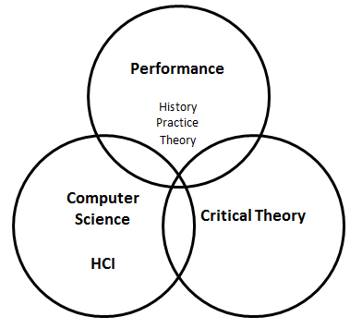
Diagram 2: interdisciplinary enquiry

The Computer Science/HCI aspect investigated the use of natural computing interfaces such as gesture and voice, combined with high performance multimodal delivery of audio, video, text and 3D graphics. The research further examined the necessary software and systems platforms that would support the production of content and deliver gaming performance – interactive real-time 3D environments.

The research was informed by contemporary critical theory on technology in theatre, interactive art, performance art examining performative notions of liveness, authenticity and improvisation.
(Auslander 2008; Broadhurst and Machon 2006; Causey 1999; Dixon and Smith 2007), illustrated below, Diagram 3: Theory and practise.
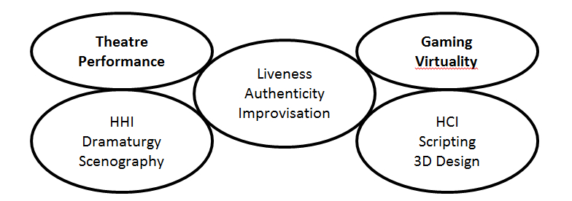
Diagram 3: Theory and practise

The practice led research began in September 2013 with the aim of creating a believable animated body projection of a virtual character using a combination of projection mapping, Kinect body tracking and a games engine. Projection mapping has been used to great effect in architectural projections and more interestingly for the creation of pop promos, live dance and performance. Video examples can be found on the webpage [Performative Examples].

In November 2013 the first prototype using the MikuMiku anime software was documented on video and subsequently demonstrated to a number of researchers in the MRL Lab. The photograph below (Image 1: MikuMiku Projection) shows the mikumiku dance character projected onto a performer wearing a white body suit.

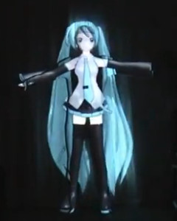
Image 1: MikuMiku Projection

The projected figure closely tracks the body of the performer producing a ‘digital bodymask’. The performer wears video glasses and via a video camera are able to witness themselves perform from the perspective of the audience. The system is illustrated diagrammatically below, Image 2: Mikumorphia system.

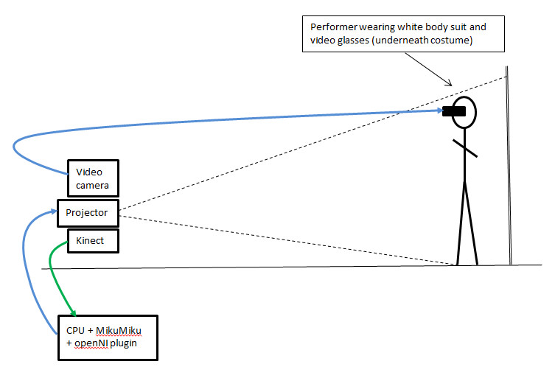
Image 2: Mikumorphia system

On trailing the system the effect was felt to be engaging and immersive; it was uncanny seeing oneself transformed into a Japanese female avatar and able to puppet a virtual body which closely followed ones movements and appeared to be mapped over one’s own body – a virtual double.

The notion of the uncanny and the double was seen as an provocative research strand and is further discussed in section, The Uncanny And The Double.

Through the practice it is was observed that the uncanny is experienced by the performer witnessing themselves transform and by audience members seeing the illusion take place live, rather than watching a video documentation which distances the witness from the event, thereby eradicating any possible evocation of the uncanny.

This sentiment echoes the loss of presence that occurs through the representation of performance in another medium.

Performance's only life is in the present. Performance cannot be saved, recorded, documented, or otherwise participate in the circulation of representations of representations: once it does so, it becomes something other than performance.
(Phelan 2012:146)

Between January and March 2014 the system was developed using the Unity Games Engine to enable the support of more realistic characters and took on the working title “iMorphia”. In April 2014, sixteen participants took part in a workshop involving a series of exercises designed to evaluate the effectiveness of the system and to gain audience and performer feedback. The participants were a mix of performers and those interested in the concept of performance. All participants reacted strongly to the change of projected gender, a number of participants voluntarily used the term uncanny when witnessing the projective illusion. It was noted that the experience of the performer is substantially different to that of an audience member, the illusion having a stronger emotional effect on the performer, whilst the effect on the spectator was felt to be more objective and thereby less easily affected.

Emergent Research Strands
Auto-ethnographic and ethnographic studies of the enactments and video and audio documentation of the workshops identified a number of potential research strands for further development, these are described below.

- Gender and body transformation, stereotypes and performative behaviour
- Control and Possession
- Improvisation and multiple performers

1. Gender and body transformation, stereotypes and performative behaviour
This would involve the creation of a range of virtual characters with differing ages, gender, build and ethnicity, a range of virtual clothing and a series of user studies in order to evaluate the effects of differing bodymasks on performative behaviour. This avenue is difficult to scope and out of remit for two reasons - the creation of multiple characters and clothing would be a time consuming task and require the skills of a 3D designer; evaluating the project requires knowledge and skills in areas such as psychology and gender studies. Such research however might have applications in mental health and well-being and the cultural studies of stereotypes.

2. Control and Possession
This area focusses on Human Computer Interaction and involves three overlapping areas of research - control, feedback and dynamics. The control aspect would investigate the mapping between the time based 3D data of the performers body movements to the bodymask - can it be improved in terms of speed and accuracy? Feedback concerns investigating the form of information delivered to the performer on the coherence between the performer’s body and the bodymask – how might the ability to follow or control the body mask be improved? Bodymask dynamics would involve the addition of interactive characteristics to the bodymask such that it has performative behaviours – it might only be able to move slowly, or may direct the performer into following certain actions or movements. This avenue of research is certainly within scope though does present technical and implementation challenges requiring low level programming and dealing with raw data rather than working at a higher level using a game engine and scripting. The strong technical focus may also steer the research away from any creative and performative practice. The research avenue may find application in training and exercises, though it is not entirely novel as there are examples of academic research and commercial applications in this area.

3. Improvisation
The concept of improvisation was included in the original PhD proposal but has not been strongly attended to in the iMorphia project. The last evaluation workshop was carried out with two performers with the premise that two performers transformed at the same time might result in improvisation. The two performers did playfully interact with each other but not in a way that suggested the emergence of improvisation. Discussion afterwards led to suggestions that a third element was required, a game, an object they could work with or perhaps a scenario designed to encourage improvisation. The system currently lacks the facility to enable the performative bodymask to interact with its virtual environment; it is simply a projected character that follows the movements of the performer. However iMorphia is implemented using the Unity Games Engine which is designed for supporting interaction and the scripting of virtual objects such that they can be imbued with performative and responsive behaviours. In addition a virtual set such as a room or a forest can be designed so supplying a context for an interactive scenario designed to encourage improvisation. The Unity platform represents a suitable vehicle for exploring the potential of creating improvisation through the addition of interactive objects and scenarios.

Early on in the research reference was made to the crossover between interactive storytelling and improvisation (Tanenbaum 2008) and the states of receptivity and engagement that encourage improvisation (Lockford & Pelias 2004), including notions such as communication, playfulness and vulnerability, these are discussed in further detail in the section, Improvisation and iMorphia.

An improvisational performance is associated with the quality of liveness, it occurs in the here and now and has a distinct quality of edginess and risk in comparison to the rehearsed and choreographed. The idea of a live interactive stage that supports improvisation resonates with discussions on intermediality described in the section Intermediality and iMorphia .

In August 2014, a second workshop was carried out to investigate whether two performers might encourage improvisation. The results of this workshop suggested that having two transformed performers does not result in improvisation and that a third element, a game or an object for the performers to interact with might encourage improvisation.

Conversation about why there was a lack of immediate improvisation gave rise to a number of suggestions including the idea that the addition of a third element for the performers to work with would give the performers something to work with and encourage improvisation. The third element could take on a number of forms, the entry of a virtual character or perhaps a virtual object that the performers could pass to each other. We all felt that a game like scenario, the throwing of a virtual (or real) ball for instance would immediately encourage play and improvisation.
(Research Blog, August 2014. )

These ideas were explored through a further series of enactments exploring notions of interaction and play and a comparative study carried out against the intermedial performance environment, PopUpPlay.

In February 2015 I attended a demonstration of PopUpPlay at Leicester De Montfort Univeristy. PopUpPlay is a projective and interactive virtual environment designed to encourage play and improvisation for young people. I recognized the improvisational and playful capabilities enabled by the environment which I felt were lacking in iMorphia.

In June 2015 I carried out an exercise with two performers comparing how the environments of iMorphia and PopUpPlay might foster play and improvisation.

Video documentation illustrates how PopUpPlay successfully facilitated improvisation and play, whilst iMorphia, despite the adding of responsive seagulls to a ball playing beach scene, resulted in a constrained game-like environment, where performers simply played ball passing with each other. A key difference is the role of the operator in PopUpPlay, a ‘Wizard of Oz’ behind the scenes director, controlling and influencing the improvisation through the choice of the virtual objects and their on-screen manipulation. IMorphia is controlled by programmed interactive scripts, and producing a ‘smart script’ designed to encourage improvisation in the same way as a human operator is likely to be a non-trivial exercise.

iMorphia presented an interaction issue with performers finding it difficult to precisely locate and interact with the virtual object’s It was noted that performers found it difficult to locate and interact with the virtual object through their real bodies.

The video glasses do not provide any depth cues of the performer in real or virtual space, and if performers are to be able to move three dimensionally in both the real and the virtual spaces in such a way that co-location and thereby real/virtual body/object interactions can occur, then a method for delivering both virtual and real world depth information will be required.
(Research Blog, June 2015. )
This issue of co-location became problematic again in the participation with props exercise, described in the section on Performative Interaction.

We discussed the differences between iMorphia and PopUpPlay and also the role of the audience, how might improvisation on the intermedial stage work from the perspective of an audience? How might iMorphia or PopUp Play be extended so as to engage both performer and audience?

All the performers felt that there were times when they wanted to be able to move into the virtual scenery, to walk down the path of the projected forest and to be able to navigate the space more fully. We felt that the performer should become more like a shamanistic guide, able to break through the invisible walls of the virtual space, to open doors, to choose where they go, to perform the role of an improvisational storyteller, and to act as a guide for the watching audience.

The vision was that of a free open interactive space, the type of spaces present in modern gaming worlds, where players are free to explore where they go in large open environments. Rather than a gaming trope, the worlds would be designed to encourage performative play rather than follow typical gaming motifs of winning, battling, scoring and so on. The computer game “Myst” (1993) was mentioned as an example of the type of game that embodied a more gentle, narrative, evocative and exploratory form of gaming.
These ideas formed the basis for the next set of enactments examining performative interaction.

Dixon’s concepts of performative interaction (navigation, participation, collaboration and communication (Dixon and Smith 2007) ) informed the practice and between August 2015 and March 2016 a series of enactments and a small workshop were carried out to evaluate how iMorphia might specifically support navigation and participation.

Performative Interaction
Interaction within gaming produces a sense of embodiment with the avatar and immersion within the game, this is also true with iMorphia, enabling an avatar to interact and affect the environment results in greater engagement and play. (For further discussion of this topic see iMorphia and Gaming).

The great advantage of participatory environments in creating immersion is their capacity to elicit behavior that endows the imaginary objects with life.
(Murray 1997 : 112)
Steve Dixon in “Digital Performance ” suggests four types of performative interaction with technology (Dixon, 2007 : 563).
- Navigation
- Participation
- Conversation
- Collaboration.
The categories are ordered in terms of complexity and depth of interaction, 1 being the simplest and 4 the more complex.
Navigation: the performer steers through the content, this might be spatially as in a video game or via hyperlinks.
Participation: the performer undergoes an exchange with the medium, for instance performing with props.
Conversation: the performer and the medium undergo a back and forth dialogue. Collaboration is when participants and media interact to produce surprising outcomes, as in improvisation.

Dixon’s concepts of participation and navigation were implemented by creating a number of interactive scenes in iMorphia and evaluated using a combination of personal enactments and a participatory study with two performers. Through my enactments I identified the following issues.

1. Projected body mask and perspective
As the performer moves away from the Kinect, the virtual character shrinks in size such that the projected body mask no longer matches the performer. Additional scripting to control the size of the avatar or altering the code in the camera script might compensate for these problems, though there may be issues associated with the differences between movements and perceived perspectives in the real and virtual spaces.
2. Co-location and feedback
The lack of three dimensional feedback in the video glasses results in the performer being unable to determine where the virtual character is in relationship to the virtual objects and thereby unable to successfully engage with the virtual objects in the scene.
3. Real/virtual interactions
There are issues associated with interactions between the virtual character and the virtual objects. In this demonstration objects can pass through each other. In the Unity games engine it is possible to add physical characteristics so that objects can push against each other, but how might this work? Can the table be pushed or should the character be stopped from moving? What are the appropriate physical dynamics between objects and characters? Should there be additional feedback, perhaps in the form of audio to represent tactile feedback when a character comes into contact with an object?

In order to further assess these issues an interaction workshop with two performers was carried out in March 2016, described below and documented on the website with video.

Interaction Workshop
A workshop involving two performers was carried out in order to re-evaluate the performative notions of participation and navigation.

Previously a series of auto-ethnographic enactments provided some initial feedback on participation and navigation with iMorphia. It was informative to observe the enactments as a witness rather than a participant and to see if the performers might experience similar problems and effects as I had.

Participation
The first study was of participation – with the performer interacting with virtual props. Here the performer was given two tasks, first to try and knock the book off the table, then to knock over the virtual furniture, a table and a chair.

The first task involving the book proved extremely difficult, with both performers confirming the same problem as I had encountered, namely knowing where the virtual characters hand was in relationship to one’s own real body. This is a result of a discrepancy in collocation between the real and the virtual body compounded by a lack of three dimensional or tactile feedback. One performer commenting “it makes me realise how much I depend on touch” underlining how important tactile feedback is when we reach for and grasp an object.

The second task of knocking the furniture was accomplished easily by both performers and prompted gestures and exclamations of satisfaction and great pleasure!

In both cases, due to the lack of mirroring in the visual feedback, initially both performers tended to either reach out with the wrong arm or move in the wrong direction when attempting to move towards or interact with a virtual prop. This left/right confusion has been noted in previous tests as we are so used to seeing ourselves in a mirror that we automatically compensate for the horizontal left right reversal.

An experiment carried out in June 2015 confirmed that a mirror image of the video would produce the familiar inversion we are used to seeing in a mirror and performers did not experience the left/right confusion. It was observed that the mirroring problem appeared to become more acute when given a task to perform involving reaching out or moving towards a virtual object.

Navigation
The second study was of navigation through a large virtual set using voice commands and body orientation. The performer can look around by saying “Look” then using their body orientation to rotate the viewpoint. “Forward” would take the viewpoint forward into the scene whilst “Backward” would make the scene retreat as the character walks out of the scene towards the audience. Control of the characters direction is again through body orientation. “Stop” makes the character stationary.

Two tests were carried out, one with the added animation of the character walking when moving, the other without the additional animation. Both performers remarking how the additional animation made them feel more involved and embodied within the scene.

Embodiment became a topic of conversation with both performers commenting on how landmarks became familiar after a short amount of time and how this memory added to their sense of being there.

Finally we discussed how two people might be embodied and interact with the enactments of participation and navigation. Participation with props was felt to be easier, whilst navigation might prove problematic, as one person has to decide and controls where to go.

A prototype two performer participation scene comprising two large blocks was tested but due to Unity problems and lack of time this was not fully realised. The idea being to enable two performers to work together to lift and place large cubes so as to construct a tower, rather like a children’s toy wood brick set.

Navigation with two performers is more problematic, even if additional performers are embodied as virtual characters, they would have to move collectively with the leader, the one who is controlling the navigation. However this might be extended to allow characters to move around a virtual set once a goal is reached or perhaps navigational control might be handed from one participant to another.

It was also observed that performers tended to lose a sense of which way they were facing during navigation. This is possibly due to two reasons – the focus on steering during navigation such that the body has to rotate more and the lack of clear visual feedback as to which way the characters body is facing, especially during moments of occlusion when the character moves through scenery such as undergrowth.

These issues of real space/virtual space co-location, performer feedback of body location and orientation in real space would need to be addressed if iMorphia were to be used in a live performance.

The Embodied Performative Turn
One of the key findings to emerge through a combination of practice and theory, praxis was the concept of the Embodied Performative Turn. The effect of giving the performers the viewpoint as if from the audience challenged conventional screen directed notions of interaction.

The section on Gaming and iMorphia expands on the similarities and difference between game play interaction directed towards a screen and theatrical interaction directed away from the screen and towards an audience. The ‘performative turn’ impacted on the design of the technical medium, giving the performer the ability to see themselves, and also to impact upon the nature of live performance and interaction with the virtual environment. The phrase, “the Embodied Performative Turn” encapsulated both these aspects.

The concept of the embodied performative turn emerged through praxis, the practice produced a technical embodiment of the idea – a technique for enabling the performer to witness themselves perform from the perspective of the audience, via video glasses and a video camera.

Definition:
An interactive virtual character is projected onto the body of the performer (the embodiment).
Video glasses enable the performer to see themselves performing from the perspective of the audience (the performative turn).

It became clear that this performative turn impacted on interaction with the virtual scene and Dixons concepts of performative interaction proved useful in guiding the research. Facing out and away from a virtual backdrop rather than looking at a screen changes the gaze of intent and interaction from “looking at” to “being in”. The Embodied Performative Turn represents a novel performative form of interaction directed at an audience whilst challenging inherent conventions of screen based interaction.

The section iMorphia and Gaming investigates the relationships between embodiment, corporeality, interaction and immersion. Contrasts between gaming and iMorphia are drawn between how the spectator or participant point of view are rendered and received and how these impact on interaction.

iMorphia and Gaming
IMorphia utilizes the games engine Unity and thereby shares some common functional and conceptual aspects present in gaming, such as the rendering of a three dimensional virtual space from a camera viewpoint, the presence of an avatar in the virtual space and the navigation of and interaction with the virtual space by a player/participant.

In contrast to film, the game engine allows the viewer control over what they see.

The game apparatus – a software engine that renders three dimensional space from an embodied perspective, directed in real time by players through a physical interface – achieves what the cinematic apparatus cannot; a sense of literal presence, and a new participatory role for the viewer.

iMorphia differs from the form and presentation of a game in that rather than a player interacting with a scene represented on a screen in front of them, the participant performs towards an audience with the screen behind them. In terms of interaction, rather than using a games controller, iMorphia makes use of the Microsoft Kinect to enable natural body centric interaction.

There are a number of Kinect dance and sports games that also use the body for controlling interaction, but these are perceptually different as the player views an avatar on screen, rather than witnessing a projected avatar on the body. Further, game play interaction is directed at the screen whilst with iMorphia it is directed out of the screen and towards an audience.

The projection of a virtual character onto the body of the participant, coupled with the video feedback enabling the participant to see themselves transformed from the perspective of the audience. This shift in perspective is discussed in detail below.

The combination of body projection and video feedback is summed up by the phrase “The Embodied Performative Turn”, this concept represents an aspect of novelty or new knowledge and insight, when considering performative notions of interaction, navigation and participation (Dixon 2007 : 563).

In the following section I refer to the literature on corporeality, immersion and embodiment in gaming and how these concepts relate to iMorphia.

Corporeality, immersion and embodiment
Immersion is often used to describe the intended experience of VR, a metaphor likening it to the experience of being submerged in water – the sensation of being surrounded by a completely other reality (Murray 1997: 98). Within gaming, rather than specifically attributing the experience of immersion to being the result of the stereoscopic perspective of the VR headset, it is also attributed to the resulting effect of interactive engagement, where the player experiences an identification and loss of awareness of their surroundings through being totally captivated by gameplay.

This notion also appears in discussions on embodiment, the identification the player makes with the gaming avatar such that the player feels as if they are in the game as a body.

Players identify with avatars as being the players’ exteriorized or doubled body images.
(Norgard 2011 : 2)

In a similar manner there are two aspects to the conditions for the production of the sensation of embodiment, one that is produced through pure visual engagement and the other being produced through interaction, where the body of the avatar engages with the virtual scenography in such a way that there is a direct relationship between player causing the avatar to move or interact with the virtual scene and the witnessing of the effect of that action.

Players are immersed in the projection, transmission or transportation to avatars as embodied minds (Norgard 2011 : 3)

Refining this further it can be stated that both the sensation of immersion and embodiment can be produced by a combination of visual engagement and player interaction – the corporealization of perception and the translation of perception into bodily movement (Lahti 2003 : 164).

Through translating the participant’s eyes into the invisible avatar within the game, as if one is looking out of the avatars eyes, the first person perspective attempts to immerse the player into the action.

(Dragged by the Gaze: The First-Person Perspective as Immersive Strategy, Patrick Rupert-Kruse)

In this way, Martthi Lahti, Bob Rehak, Alison McMahan as well as Cathy Cleland privileges ‘first-person’ visual perspective as being the most ‘immersive’ (McMahan 2003: 67), ‘embodied, (Cleland 2010: 85), ‘subjective’ and unifying’ (Lahti 2003: 161) and as causing ‘corporeal immersion’ and ‘sensory immersion’ (Rehak 2003: 118). Thus, they are all in agreement on the fact that: ‘Differing articulations between camera-body and avatar-body lead to different, though related, modes of play and subject effects.’ (Rehak 2003: 109).
(Norgard 2011 : 7)

Third person perspective results in a slight disengagement, where the back of the player’s avatar is visible, as if looking just around the head of the avatar. In contrast iMorphia utilises a second person perspective, where the projected avatar is displayed from the perspective of a camera that is always in front of the avatar. This perspective is somewhat novel and only used in gaming as cut away shots, for instance a view from security camera. The perspective is more common in films, where the camera is used to create the illusion of you being an inviable third party watching the action, with the camera is on the actors often cutting back and forth from one actor to another as they are engaged in dialogue.

My supervisor Steve Benford suggested that the film-like theatrical perspective of iMorphia might be named a 4th person perspective, and resonates with the concept of the theatrical 4th wall.

The table below summarizes these perspectival differences between gaming and iMorphia.

 | Gaming Player | iMorphia Performer
Embodiment | First/third person perspective of avatar viewed on a screen. | Fourth person perspective of projected character witnessed through video glasses.
Perception | “I am there/I am it” | “It is I”

There is an argument that first generation VR sought to make the participant lose sense of their own body, whilst subsequent and more recent mixed reality technologies involve reintroducing the body as important if not essential in the interactive experience. With reference to the philosophers Merleau -Ponty and Heidegger, these notions tie into issues of corporeality and phenomenology,

Phenomenology, via both Merleau-Ponty and Heidegger, not only prioritizes the body as epistemic condition of knowledge, but can also situate technics or ‘equipmentality’ in primary relation with that body, as mutually imbricated in the processes of knowing and perception.
(Harper C, Richardson I. 2001)

A further form of embodiment is that of dramaturgy where avatars engage or interact with other avatars, this is represented in iMorphia through the transformation of two performers at the same time.
Player-avatar identity is framed as a relation of escapism wherein players are immersed in the role-playing or performance of avatars as fictional characters. (Norgard 2011 : 3)

How the avatar body appears on screen and how it operates within a game can be viewed as prosthesis acting as a conduit for embodiment.

Player-avatar identity as a relation of cyborgian extension wherein players are immersed in prosthetic technology and avatars. (Norgard 2011 : 4)

Norgard goes further to emphasise the importance of avatar interaction over visual appearance:

On the grounds of the body schema the avatarian connection is meaningful because of what players are capable of doing because of it, and not because of what players are capable of looking like or looking at because of it. Hence, the avatarian connection is more a question of corporeal-locomotive capabilities than of visual perception or appearance.
(Norgard 2011 : 6)

The diagram below (NORGARD 2011 : 12) summarises aspects of player-avatar identity:
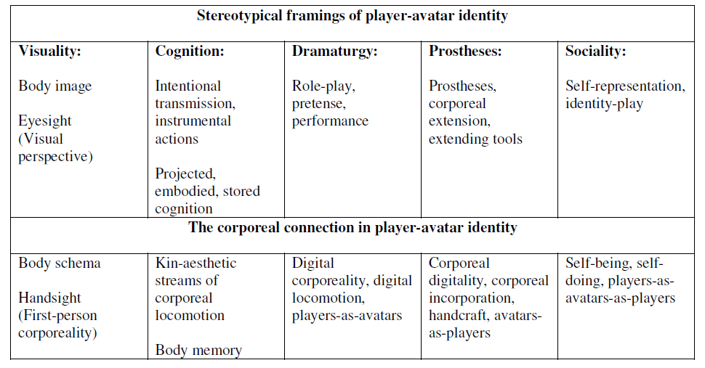
Diagram 4: player-avatar identity (NORGARD 2011 : 12)

The notion of the avatarian connection resonates with identification a performer makes whilst in iMorphia. In a similar manner to the way gamers identify with the onscreen avatar, performers engage and identify with the projected body they see relayed through their video glasses of a camera showing the audience viewpoint. And parallel to filmic techniques setting the scene, the projected theatrical backdrop is displayed from the perspective of an invisible camera, the fourth person perspective.

In addition to the visual representation important for avatar identity, interaction through intention and corporality with the virtual world is seen as an important aspect of embodiment.

Avatar Representation
The evaluation of iMorphia through enactments and workshops produced a number of observations, one being how the physical appearance of the avatar affected performative behavior, especially gender. The user study demonstrated how females performed being a male avatar and vice versa and how participants remarked on how immediately it would affect their behavior – female participant: “You adopt a male stance straight away”; male: “I am surprised how the image affects me, I want to put my hand on my hips”.
The early MikuMorphia enactment revealed how my own performative behavior was dictated by ‘being’ the female MikuMiku dance character, especially the long hair which encouraged movements designed to make the hair swing.

The changing of gender through technology can be linked to the concept of the cyborg:
Cyborgization is partially driven by a desire to try on different bodies, to trespass or toy with racial and sexual boundaries, underlining psychic and social structures motivating racial and sexual cross dressing
(Lahti 2003: 167)

The design of the appearance of the avatar opens up many possibilities – age, sex, body shape, height and clothing. Software tools such as Daz3D studio enable users to design and clothe avatars, choosing from a library of avatar models, clothing and accessories. The avatars available often appear somewhat sexualized, perhaps stereotypically designed to appeal to a male audience.

Games also insisted on manufacturing increasingly exotic fantasy selves, defined sharply by categorical difference, otherness from oneself. And games have done this by offering a simultaneous experience of disembodied perception and yet an embodied relation to technology.
(Lahti 2003: 168)

However it is possible to produce more realistic and generally believable avatars rather than idealized fantasy figures using plugins to change the body shape and age. MakeHuman an open source avatar designer (http://www.makehuman.org/) enables the user to completely customize the avatar, body shape, ethnicity, age, gender, muscle tone, facial features and so forth.

Such tools open up the possibility of creating a whole range of avatars to see how performative behavior might be modified. Having a range of avatars performers could adopt also creates the possibility of drama with performers taking on different roles and characters. It opens up a wide field of possibilities with interesting implications as the literature notes:

We are lured into a supermarket of bodies and body parts from which the players representation her virtual self can be created and customized.
Unhinged from contexts of social inequalities the body her is aestheticized as variety itself turning it into a mutable fashion statement, an adaptable task-orientated instrument, or a toy which we can play.
(Lahti 2003: 166)

The practice research highlighted how the projected body image affected how a participant felt and performed, however it was felt that researching the impact of avatar appearance on behavior was beyond scope, there were too many possibilities to explore and many potential areas of critical impact to consider in relationship to gender, ethnicity, and the semiotics of symbols, signs and meaning considered in theatre studies. Indeed there are parallels between staging a real drama, designing the set, the costumes and the design of the virtual stage of iMorphia.

Intermediality and iMorphia
On commencing the research it proved problematic to find a term for describing the interactive projective medium I envisaged as a vehicle for performance, the literature describing a range of technology enhanced forms of theatre – virtual theatre, digital theatre, augmented theatre. Originally I used the term multimodal performance as a means of envisaging a system capable of both delivering and responding to a number of forms of input and output, including digital sound, video, graphics and the ability to respond to voice, movement, gesture.

The notion of live performative improvisation with technology suggested a medium that shares the responsiveness of gaming translated into a witnessed performance context and embracing notions of authenticity, presence and liveness (Phelan 2012, Auslander 2008).

Joe Scott describes herself as an intermedial performer and her work involves not only revealing the processes of constructing intermedial work, but also placing herself in a position of risk, manipulating media in real time so as to imbue a sense of liveness that embraces improvisation and spontaneity.

Within live intermedial performance, liveness exists within, through and in relation to
the media employed and is enacted and engendered by manipulation of such media
by the performer/activator in the real time of performance.
(Scott 2012: 8)
In her paper, “Dispersed and Dislocated: The construction of liveness in live intermedial performance”, Scott (2012) discusses how her practice based research informs theories on liveness and intermediality, arguing that two essential elements to creating a sense of liveness is the real-time nature of the technology enhanced performance unfolding in space and time and the unpredictability of its direction at any moment in time.

What became evident was that, as a solo performer, my intermedial kit offered me a number of diverse opportunities to 'make things live'; that is to construct intermediality in the moment of performance. This led me firstly to occupy a dual role on stage, both performing and activating the various elements of performance. It also led me to want to investigate how liveness manifested itself on a stage, where the performer/activator could construct the performance in real time and in the presence of the spectators and where the mechanics of this intermedial construction were part of the performance. (Scott 2012)

The performer becomes a medium, a conduit for interacting with and imbuing meaning in the various forms of intermedia she engages with. It is this concept I find interesting, the live engagement, “the performing of the interface” in real time, producing presence and authenticity. Multimedia theatre on the other hand appears more akin to a stage prop, a backdrop against which the actor performs.

The term intermedia originated from the Fluxus artist Dick Higgins, who in his essay of 1965 attributes the original use of the term to Samuel Colleridge (Higgins 2001: 52). Higgins uses the term in recognition of the multiple media and forms of art taking place at the time; he also cites Duchamp, Dada and the Futurists as practitioners of intermedia arts. Higgins goes further than simply to say an art that uses mixed or multimedia is intermedia and in 1981 he suggests that intermedia is perhaps best seen as a conceptual method in creating new work.

And with this I would leave the matter of intermedia. It is today, as it was in 1965, a useful way to approach some new work; one asks oneself, “what that I know does this new work lie between?” But it is more useful at the outset of a critical process than at the later stages of it.
(Higgins 2001: 53)

In 2014 intermedia had become a blanket term to describe almost all media, especially with the advent of the digital which embraces previously disparate media – text, image, video and sound.

The term itself is very broad and functions as an umbrella term, limited neither to a specific phenomenon or media, nor to specific research objectives.
(Sakoparnig 2012: 2)

Examining the use of intermediality within a performance context it becomes clear that it is not specifically about the nature of media or in-between media types, but instead concerns itself with the relationship between the performer and media.
..intermediality is very much about the staging (in the sense of conscious self-presentation to another) of media, for which theatre as a hypermedium provides pre-eminently a stage.
(Kattenbelt 2010: 29)

This concept marries with the definition of intermedia by Giesekam (2007:8) where he contrasts intermedia with multimedia productions.

For the second type of production, where more extensive interaction between the performers and various media reshapes notions of character and acting, where neither the live material nor the recorded material would make much sense without the other, and where often the interaction between the media substantially modifies how the respective media conventionally function and invites reflection upon their nature and methods, I would suggest the term ‘intermedia’ is more appropriate.
These concerns with intermediality served to critically inform the practice based research process, specifically highlighting notions of interaction, liveness and improvisation. Informed by theory, iMorphia developed away from the early interests in spectacle and transformation, the associated notions of the uncanny to become directed towards examining the theory and practice of performance and interaction, described in the section Performative Interaction.

Improvisation and iMorphia
Computer-aided improvisation is generally associated with music and there is an overwhelming amount of research literature in this field, probably because electronic music has a long history in connection with computing and music with its close relationship to mathematics is more amenable to digital representation and mediation than visual performance.

The Performing Arts, especially dance, tend to use technology as interpretive media rather than for live improvisation. There is a gap in the use of technology for the production of live multimodal improvisation combining voice and gesture with mediation.
The paper “Liveness and the machine : Improvisation in Live Audio-Visual Performance” Cooke (2011) describes live audio-visual performance as an emerging area of new media arts practice that crosses between, and draws upon, multiple artistic traditions and trajectories. Cooke refers to the parallels with VJing, Live and Expanded Cinema and examines concepts of liveness in relationship to improvisation and spontaneity.

Liveness and authenticity are important concerns within the culture of performance, especially in relationship to documentation and technological mediation (Auslander 2008).

The relatively new term ‘comprovisation’ describes a semi structured space somewhere between composition and improvisation.
Likewise, many writers on improvisation testify to the problematic of distinguishing between spontaneous creation and pre-existing structure or motif; the term ‘comprovisation’ has arisen as a way of recognising the intricate interweaving of the com-posed with the improvised.
Cooke (2011:11)

A conference on technology and the performing arts entitled “Comprovisations” held in 2010 (Bhagwati 2010) discussed how technologies would transform the aesthetics and practises of stage performance and engender new production modes as well as call into play audience reactions to technology enhanced performance.
Contributors to the workshops were predominantly electronic music performers, probably because comprovisation is a term associated with improvised music – a place in between improvisation and composition.
Due to the abundance of research in music improvisation and technology, research of the differences and potential overlap between music and the visual arts is required to determine if there are any common grounds between visual and aural languages. This area might also be further understood through the methodologies of multimodal studies and semiotics. The following quote with its multiple references indicates a wide area of research in this field.

In the first sense, multimodal studies applies existing generalisations (of theory, description, methodology) to the exploration of specific multimodal phenomena, sets of texts or contexts in order to cast new light on those domains. Such domains might be more broadly defined areas of multimodality; e.g. ‘language of displayed art’ (O'Toole, 1994), ‘grammar of visual design’ (Kress & van Leeuwen, 2006), ‘speech, music, sound’ (van Leeuwen, 1999), ‘mathematics discourse’ (O'Halloran, 2005); particular (sets of) semiotic resources in interaction; e.g. images and text (e.g. Martinec, 2005; Unsworth & Cleirigh, 2009) and gesture and phonology (e.g. Zappavigna, Cleirigh, Dwyer, & Martin, 2010); or sites where multimodal discourse is at issue, such as classroom discourse (e.g. Clarke, 2001; Jewitt, 2006), and interactive digital media such as games, the internet, video and corporate advertising etc (e.g. Jewitt, 2009; Ventola & Moya, 2009).
(O’Halloran 2011:4)

In the paper “Designing the Spectator Experience” (Reeves 2005), the spectator’s perception of differing types of perceived interactions with technology are analysed in order to suggest a taxonomy of modalities:

Our taxonomy uncovers four broad design strategies: ‘secretive,’ where manipulations and effects are largely hidden; ‘expressive,’ where they tend to be revealed enabling the spectator to fully appreciate the performer’s interaction; ‘magical,’ where effects are revealed but the manipulations that caused them are hidden; and finally ‘suspenseful,’ where manipulations are apparent but effects are only revealed as the spectator takes their turn.

The audience’s perception and comprehension of technology enhanced performance is recognised as an important if not problematical research area, with the term “The Disembodiment Problem” (Marrin Nakra 2000) used to describe the disjunction between cause and effect when using interactive technology to produce music. This problem can also be viewed as a challenge and perhaps a quality of technology when used in a performance context and is treated as such in the paper “Disembodied Performance: Abstraction of Representation in Live Theater” (Torpey 2009).
In the paper Bodily Poeticizing in Theatrical Improvisation: A Typology of Performative Knowledge, Lockford and Pelias (2004) describe five different types of knowledge that live performers draw on in improvisation: communication, playfulness, sedimentation, sensuality, and vulnerability. Tanenbaum (2008) applied the typology to gaming and interactive narrative, contextualising game interactors as performers.

Communication: Are the actors engaged in an ongoing process of negotiating and coordinating their characters and themselves through interaction? Do the actors seem connected, listening to and incorporating what each other is saying? Are they adjusting their thinking and action according to what they are hearing? Are they producing a coherent story?

Playfulness: Are the actors open to possibilities? Are they functioning with spontaneity and imagination? Are they playing with language? Are they recognizing linguistic and social constraints? Are they working within the limits of the given circumstances? Have the actors moved beyond established patterns to the “intricacies” of the scene?

Sedimentation: Are the actors relying upon lifetime structures of learning?
Are they trusting their bodies, following their impulses, paying attention to what feels right? Have they become reflective about their hidden, tacit knowledge? Have they considered the degree to which their sedimented behaviors match those of their characters?

Sensuality: Are the actors’ senses alive, ready, actively engaged? Are the actors taking in what they need? Are the actors feeling with their bodies?
Are they open to the pleasures of sensory response?

Vulnerability: Are the actors willing to put themselves at risk? Are they willing to try to make difficult situations work? When feeling vulnerable, do they have the ability to keep the focus on what needs to be accomplished?
Are the actors willing to trust one another?
(Lockford and Pelias 2004)

By treating the interactor as a performer and engaging her in an implicit contract with the system, this notion draws on rules of conduct that have been used for years to guide and structure improvisation between human actors. In an improvisational scene, all of the participants are responsible for the overall quality of the scene, and all of the participants must rely on each other in order to succeed. As a result, all of the participants are simultaneously vulnerable and responsible; at the mercy of their fellow actors, and able to make or break the scene for the other participants.
(Tanenbaum 2008:213)

The Uncanny And The Double
The Uncanny according to the OED is defined as “strange or mysterious, especially in an unsettling way” and originated from the Scottish – not-canny relating to the occult and the malicious. The etymology of the word resonates with the German Das Unheimliche, "the opposite of what is familiar”, a concept expounded upon by Sigmund Freud in his 1919 essay The Uncanny (Freud 1919). Freud also refers to another German writer and psychiatrist, Ernst Jentsch, who in 1906 wrote the essay, On the Psychology of the Uncanny (Jentsch 1906).

In films utilising computer graphics the uncanny is to be avoided as it distances the viewer, challenging their suspension of disbelief in believing what they are watching is actually human rather than something alien and hybrid. The Uncanny Valley (Mori 1970) illustrated below (Image 3: The Uncanny Valley) describes a trough to be avoided in the design of robotics, on the left we perceive things as non-human and on the right they are recognised as clearly human, the trough is the in-between space, a liminal and discomforting area where objects appear uncomfortable and disturbing neither really alive in a human sense or dead as in non-living.
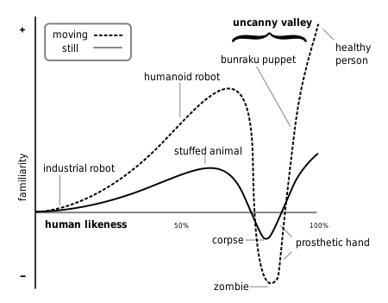
Image 3: The Uncanny Valley

In his essay Freud refers to the earlier work of Jentsch and shares a definition of the circumstances that evoke a sense of the uncanny which mirrors the uncanny valley as described above.

..doubt as to whether an apparently living being really is animate and, conversely,
doubt as to whether a lifeless object may not in fact be animate
(Jentsch 1906: 8)

Freud applies his theories of repression and the subconscious the uncanny whilst Jentsch takes a different approach examining the writings of the Sand-Man by Hoffman as a source for how literature makes use of the uncanny. In his essay Freud appears to dismiss Jentsch’s intellectual approach in the analysis of Hoffman, and suggest that the uncanny is brought about by complexes involving castration.

We shall venture, therefore, to refer the uncanny effect of the Sand-Man to the child’s dread in relation to its castration- complex. But having gained the idea that we can take this infantile factor to account for feelings of uncanniness, we are drawn to examine whether we can apply it to other instances of uncanny things.
(Freud 1919: 8)

Freud emphasises that the uncanny is brought about from a reawakening of repressed childhood memories that make the familiar seem strange and disturbing. He argues against the view of the uncanny held by Jentsch, who believes the uncanny is a feeling that results from certain phenomena which produce an intellectual uncertainty that challenges the human need for intellectual mastery over its environment.

So if one wants to come closer to the essence of the uncanny, it is better not to ask what it
is, but rather to investigate how the affective excitement of the uncanny arises in psychological terms, how the psychical conditions must be constituted so that the ‘uncanny’ sensation emerges.
(Jentsch 1906: 3)

Rather than taking a Freudian approach to the uncanny, the quest for determining the conditions for how the uncanny sensation emerges suggests a line of practise based experimental enquiry for the iMorphia project.

Freud also refers to the writings of Otto Rank (Fredu 1919: 9) and his association of the uncanny with the double or doppelganger. This theme has been more recently taken up in the field of performance and technology by writers such as Causey and Dixon who writes about the digital double (Dixon 2007: 241).

The screens of mediated technologies, now ubiquitous in live performance, like the dolls, mirrors and automatons which Freud suggests bring forth experience, construct the space wherein we double ourselves and perform a witnessing of ourselves as other. The uncanniness of mediatized culture is a technological uncanniness.
(Causey 1999: 386)

Theatre and Media Technologies
The use of technologies to create enhanced visceral theatre has a history ranging from the 18thC Phantasmagoria using the magic lantern (an early form of image projection), through to the Futurist’s SyntheticTheatre of 1915 and the more recent productions using the relatively new technologies of digital computing, projection and sensing.
It appears that contemporary dance has embraced the new technologies more so than theatre and currently continues to do so. Perhaps the form offers more freedom and scope for abstraction than the traditional theatre.
Perhaps it is the traditional nature of theatre with its teams of actors, directors, playrights and scenographers that restrain the experimental, and only in the smaller companies we see innovation and an embrace of contemporary technology as a means of creative expression. Theatrical productions that do break the traditional mould are led by visionary directors or work with visionary scenographers.
Josef Svoboda (1920-2002) produced some of the first early dynamic uses of kinetic scenography using moving sets, lighting, electronics, mirrors, film and slide projections. His vision was that the stage should marry with the psycho dynamics of the dramatic space, it should change in response to the drama and not be a static backdrop. One of his early works was created in 1958, when he and director Alfred Radok developed Laterna Magika, which combined live action and filmed sequences for Expo 58 in Brussels.
A more contemporary figure is Robert Lepage who in 1994 founded the ground breaking company Ex Machina.
“Ex Machina’s creative team believes that the performing arts – dance, opera, music – should be mixed with recorded arts – filmmaking, video art and multimedia. That there must be meetings between scientists and playwrights, between set painters and architects, and between artists from Québec and the rest of the world.”
Unlike theatre, performance art and the interactive arts have pushed the boundaries of what is possible from the earliest experiments with computers in the 1960’s to the present day. Experimental artists have embraced a wide range of technologies, electronics, computers, video, telepresence, robotics, sensing, writing software and algorithms; and in doing so, produced new media and new experiences.
In the early 21st century computer gaming and theatre appear to be intersecting, Punch Drunk (est. 2000) create immersive game like forms of participatory theatre whilst Blast Theory (est. 1991) have produced a number of urban outdoor theatrical experiences using mobile technologies.

Digital Theatre
Digital Theatre describes the combining of multimodal digital technology including interactivity, audio and projection with theatre – an audience a stage and a set and actors.
Its history is relatively recent, perhaps dating from around 1985, when computers and data projectors were first becoming relatively accessible by artistic creators. The history of interactive computer art dates back further, harking back to the 60;s with Cybernetic Serendipity in 1968. However I would suggest that one of the earliest innovative interactive live performance art works using projection and digital computers is Videoplace by Myron Kreuger (1989), who in 1973 coined the term Artificial Reality.

The website, Digital Theater A Historical Survey by Casey Caldwell documents a number of a key and influential theatrical productions that use multimodal technologies, dating from 1980 through to 2012.
Casey cites the work of Julie Martin with her Virtual Reality Theatre Company as being “one of the first directors to take advantage of new media and technological opportunities for use on the stage. Her production of Shakespeare’s A Midsummer Night’s Dream in 1990 used new forms of media and projection to create a unique space that the play had never been performed in before.”
The ubiquitous accessibility and availability of technology, creative tools and open source platforms have resulted in an ever expanding foray and the blending of boundaries across disciplines, media and art forms. As a result, there are many examples of academic research centres exploring the potential of interactive digital media for theatrical applications, performance and improvisation. A number of these are listed below and on the research website .

Technology and theatre research
The Virtual Theatricality Lab has established itself as a cutting-edge leader with the development of a revitalizing curriculum that unites the disciplines of computer science, art, music, theater, dance, film, and video. The VTL is dedicated to forging the live performance technologies of the 21st century and beyond.
The Gertrude Stein Repertory Theatre (GSRT) was founded in 1990 to promote and support innovation in the performing arts. To achieve its mission, GSRT is pioneering the application of new technologies to the process of creating live theater. To advance its creative work GSRT has conducted a wide range of research and workshop activities that are facilitated and enhanced by advanced Internet, film, and theater technologies.
Centre for Contemporary and Digital Performance (CCDP)
The polycentric emphases in the new research environment rest on a distinctive transdisciplinary vision which fuses artistic performance, theatre and live art with new media technologies and creative software writing/engineering. Open to partnerships in research collaboration with others in the School of Arts, the School of Engineering and Design, and other centers and institutions elsewhere in the UK and abroad, the core group activities centre on the integration of creative arts, performance writing, directing, choreography and performance design with digital technologies. investigating new and exciting opportunities for working at the frontiers of art, science, and technology, where new modes of performance and interaction are invented.
The Search for Digital Theatre documents the research of Nadja Masura towards a doctoral thesis.
“It is a resource and product of the online research I explored in pursuit of understanding about the term “digital theatre” and forms of digital performance. It marks the path I’ve walked so far in attempting to connect resources for collaboration both on and off campus.It also shows my interactions with practitioners, theorists, technicians and my own process of experimentation and discovery with performance technology and integrative the live and the virtual.”

AlKamie, set up by Robyn Stuart and Brian Curson, develops and exploits the use of animated digital projections in dance, performance, theatre and commerce.
“alKamie create Virtual Reality Theatre which coalesces the alive tangibility of real performers with projected virtual reality to create a hallucinogenic theatre through which onstage characters and audiences tumble alike.”
Dan Zellner, Studio Z, 1992 – 2007
I founded and was Artistic Director of Studio Z. The company started out as a play reading group but then went on to work with multimedia and the Internet. Studio Z was the first company to use the Internet for a playwright exchange and also hosted one of the first sites featuring Chicago theaters (at the time only a handful of theatre had websites). As part of Studio Z, I wrote plays for a variety of digital stages: virtual worlds, game type environments, mono and 3D projected stages and even Jim Mayhercy’s Digital Kitchen: a dinner theatre that featured a live tv studio next door. I also played in these environments.
The Media and Performance LAB (MAPLAB) is founded by the Research Centre Theatre Making Processes at the Faculty of Theatre, Utrecht School of the Arts. It is initiated and led by Joris Weijdom, head of the research group Virtual Theatre.
The main goal of the MAPLAB is to provide a space for research into the possibilities of interactive technology in a performative context, and to translate this into didactic strategies.

The Improvisational Theater Space (MIT 1997) is an interactive stage where human actors can perform accompanied by virtual actors. Virtual actors are modelled as animated “Media Creatures” that are behavior-based autonomous software agents. It uses real time computer vision, speech recognition and and speech analysis to sense the performer’s actions on stage. We used Artificial Life programming methods and behavior-based design to avoid rigid scripting of user and content interaction. The main result of this work is the construction of animated media creatures endowed with intentionality and autonomous behaviors. Media Creatures allow content to be active and to present itself to the user by dynamically adapting to the context of the interaction. We used Media Creatures to create an engaging Improvisational Theater Space where the user/performer is engaged in an improvisational dialogue with a typographic actor.
The Digital Improv Project is a multi-year investigation into the roots of human creativity as it relates to the development of artificial intelligence (AI). Started in 2008, the Digital Improv Project examines the cognitive functions of improv actors through the process of protocol analysis and behavioral coding. The end goal of this process has been to establish approaches to computational creativity that can then be employed in co-creative experiences with AI characters. This work has yielded several prototype experiences where humans and AI actors can play improv games together, such as Party Quirks and Three Line Scene.
May 24-27, 2012 ⋅ Hexagram Concordia & matralab, Concordia University Montréal COMPROVISATIONS – Improvisation Technologies for the Performing Arts” is a workshop during which leading researchers, artists and software developers from Europe, Asia and the Americas will discuss questions and artistic approaches in the emerging and fast-growing field of computer-assisted improvisation in Music, Theatre and Dance.

References
Auslander, P. 2008. Liveness: Performance in a Mediatized Culture, London and New York: Routledge.

Bay-Cheng, S. Kattenbelt, C. Lavender, A. Nelson R. (eds). 2010. Mapping Intermediality in Performance, Amsterdam University Press.

Broadhurst, S. 2011. Performance and Technology: Practices of Virtual Embodiment and Interactivity

Causey, M. 1999. The Screen Test of the Double: The Uncanny Performer in the Space of Technology. Theatre Journal 51.4 (1999) 383-394. Johns Hopkins University Press.

Dixon, S. 2007. Digital Performance: A History of New Media in Theater, Dance, Performance Art, and Installation. MIT Press.

Freud, S. 1919. The Uncanny.

Giesekam, G. 2007. Staging the Screen: The Use of Film and Video in Theatre. Theatre and Performance Practices Series. New York: Palgrave Macmillan.

Harper C, Richardson I. 2001. Corporeal Virtuality: The Impossibility of a Fleshless Ontology,
Murdoch University.

Haseman, B. 2006. A Manifesto for Performative Research. Media International Australia incorporating Culture and Policy, theme issue "Practice-led Research"(no. 118):pp. 98-106.
http://eprints.qut.edu.au/3999/01/3999_1.pdf [15/4/2013]

Higgins, D. Higgins, H. 2001. Intermedia. Leonardo, Volume 34, Number 1, February 2001, pp. 49-54. MIT Press.

Jentsch, E. 1906. On the Psychology of the Uncanny.
Lahti, M. 2003. As we become Machines. The Video Game Reader. Perron N, Wolf J P (eds). Routledge 2003, ch7, pp. 157-171.

Lockford, L., & Pelias, R. J. (2004). Bodily Poeticizing in Theatrical Improvisation: A Typology of Performative Knowledge. Theatre Topics, 14(2), 431‐443.

Marinetti, F.T., Settimelli, E., Corra, B., Cowan, S. 1915. The Synthetic Futurist Theatre.
The Drama Review: TDR, Vol. 15, No. 1 (Autumn, 1970), pp. 142-146. MIT Press.
http://www.jstor.org/stable/1144612 [16/3/2013]

Murray J H. 1997. Hamlet on the holodeck MIT

Phelan, P. 2012 Unmarked: The Politics of Performance, London, New York: Routledge.

Nelson, R. 2013. Practice as Research in the Arts, Principles, Protocols, Pedagogies, Resistances. Palgrave Macmillan.

Nørgård, R T. 2011. The Joy of Doing: The Corporeal Connection in Player-Avatar Identity. Paper, Philosophy of Computer Games Conference 2011, Athens, Greece.
http://gameconference2011.files.wordpress.com/2010/10/thejoy1.pdf

Obermaier, K. 1998. D.A.V.E. Digital Amplified Video Engine
https://www.youtube.com/watch?v=1bhNjYTQFQY [7/8/2014]

Rajewsky, I. 2005. Intermediality, Intertextuality, and Remediation: A Literary Perspective on Intermediality. History and Theory of the Arts, Literature and Technologies, n° 6, 2005, p. 43-64.

Salter, C. 2010. Entangled: Technology and the Transformation of Performance. MIT Press.

Scott, J. (2012) Dispersed and Dislocated: the construction of liveness in live intermedial performance, Perspectives Paper in Body, Space & Technology Journal, Vol.11/No.1.
http://people.brunel.ac.uk/bst/vol1101/joscott/home.html [9/11/2014]

Tanenbaum, J. (2008) Believability, adaptivity, and performativity: three lenses for the analysis of interactive storytelling. Thesis. B.A. University of Redlands, 2002

Willow. 2012. Sweater (Projection mapping pop promo)
http://vimeo.com/45569479 [7/8/2014]

Yu Higuchi. 2008. MikuMiku Dance software.
http://www.geocities.jp/higuchuu4/index_e.htm [7/8/2014]

Bibliography
Auslander, Philip. 2008. Liveness: Performance in a Mediatized Culture. 2nd ed. London ; New York: Routledge.
Broadhurst, Susan, and Josephine Machon, eds. 2006. Performance and Technology: Practices of Virtual Embodiment and Interactivity. Houndsmills, Basingstoke, Hampshire ; New York: Palgrave Macmillan.
Causey, Mathew. 1999. ‘The Screen Test of the Double: The Uncanny Performer in the Space of Technology.’ Theatre Journal 51.4. Johns Hopkins University Press (1999), 386.
Dixon, Steve, and Barry Smith. 2007. Digital Performance: A History of New Media in Theater, Dance, Performance Art, and Installation. Cambridge, Mass.: MIT Press.
Haseman, Brad, and others. 2006. ‘A Manifesto for Performative Research’. http://search.informit.com.au/documentSummary;dn=010497030622521;res=IELLCC.

http://kinectic.net/category/research-blog/
Evaluating a Dancer’s Performance using Kinect-based Skeleton Tracking, Proceedings of the 19th ACM international conference on Multimedia, pp 659-662, ACM New York, NY, USA ©2011 And “Your Shape Fitness Evolved” 2012 - Xbox 360, Ubisoft.
http://kinectic.net/evaluation-workshop-two-performers/
http://kinectic.net/intermedial-workshop-1/
http://kinectic.net/imorphia-interaction-workshop/

